## Do global real estate prices co-vary with global inflation, interest rate and output growth?

Jaweria Asif – 15054

Muhammad Saad – 18125

Sarfaraz Jamal – 17093

Contents

Introduction 2

Literature Review 2

Methodology 2

USA 2

Linear Regression Model 2

Interpretations 3

Global f-test 3

Residual Normality Test 3

Ramsay RESET Test 4

Chow Test 5

Log-log Model 5

Interpretations 5

Global F-test 6

Residual Normality Test 6

Ramsay Reset Test 7

Chow Test 7

UK 7

Log-log Model 8

Interpretation 8

Global F-test 9

Residual Normality Test 9

Ramsay Reset Test 9

Chow Test 9

GERMANY 10

Interpretation 11

Global F-test 11

Residual Normality Test 11

Ramsay RESET Test 12

Chow Test 12

Conclusion 13

# Introduction

There are various economic theories that indicate that there is significant impact on the economy of a country due to changes in real estate prices. Real estate prices are impacted by real interest rates, output growth and inflation. Hence, in this paper, the aim is to study the link between real estate prices and the three macroeconomic variable that are real interest rates, output growth, and inflation. Different trends can be seen in different countries around the world, however, globally we see similar effects. This article will perform an empirical analysis to understand the existent relationship between the independent and dependent variables, the dependent being house prices. The countries chosen for this research paper are United States of America, United Kingdom, and Germany. Cross-Country quarterly data for GDP, interest rates, price index of each country has been taken through verified sources. The paper makes use of econometric models to understand the impact of the variables on real estate prices. The importance to conduct these researches is derived from the fact that asset prices all over the world have increased drastically in recent years and hence, from a macroeconomic point of view, global economy is affected by property prices. Therefore, policy makers have to be vigilant of changes in the real estate prices as it has important implications on the performance of a country’s economy. The choice of countries for this paper is based on availability of sound data and on the countries’ global influence on world’s economy being some of the world’s most developed countries. The thesis of this paper, therefore, is the claim that there is a unidirectional change in real estate prices due to changes in the selected macroeconomic variables. The paper is divided into following sections: introduction, literature review, methodology, econometric analysis of USA, econometric analysis of UK, econometric analysis of Germany, conclusion and discussion, and references.

# Literature Review

A lot of research has already been conducted to study the impact of real estate prices on the economies of countries and the contribution of macroeconomic variables in fueling that change. In a research done by Meidani, Zabihi, and Ashena (2011) on the house prices in Iran due to economic output and inflation, it was found that there is significant evidence which confirms that house prices are indeed affected by macroeconomic variables. It also shows a direct relationship between GDP and house prices. As GDP would increase, demand for real estate would rise which would consequently also raise real estate prices. In the study on the real estate prices in UK by Cetkovic et al., (2018) which has made use of neural networks for even more precision in results, also indicates a significant relationship between the macroeconomic variables and real estate prices.

In another research done on rising house prices with cross-country data by Sabyasachi (2019), it was found that per capita GDP, GDP growth rate, inflation, and exchange rate, have a statistically significant impact on house prices. However, it is important to note here that this study also makes use of other important macroeconomic variables that are not being accounted for in this research. These variables are population growth, urbanization, income, and age of population to name a few. Government policies need to be designed and modified in a way that they control money supply, inflation, employment, et cetera in order to control real estate prices.

The relationship and impacts of these macroeconomic variables are best observed in developed countries as the determinants that affect the demand and supply of real estate are more prominently seen in those countries (Cohen, Karpavičiūtė, 2017). This derives support for the choice of countries for this paper.

# Methodology

In this paper we have used 44 years of data ranging from 1975 to 2019 for USA, UK and Germany. The data being used is arranged quarterly with 180 data points. All the data was taken from the verified source FRED, Federal Reserve Bank of St. Louis. This paper makes use for econometric models for conducting empirical analysis. The four main tests used are Global F test, JB normality test, Ramsey RESET test, and Chow test. The global F-test is used to test the overall significance of the model and whether or not the variables fir properly or not. F-test is a recommended test instead of the simple t-test because the latter can only access one regression coefficient at a time where as global f-test has no such limitation. Then the JB normality test is applied which is used to check whether the data is normally distributed or not. This is important because normality is one of the assumptions that need to be satisfied for a regression model to hold. Moving on, the Ramsey RESET test is applied to check if there is any misspecification in the model due to omission of important variables or the use of wrong functional form. Lastly, the paper makes use of Chow test shows us if there are any structural breaks in the data. As mentioned earlier our regression model has the real estate prices as the dependent variable and real interest rates, GDP growth, and inflation are taken as independent variables. The functional form of the regression models was taken initially in the lin-lin form for each country except Germany and then log-log form was taken in case of misspecification found via the Ramsey RESET test. In case of Germany, the polynomial functional form is used for the regression model.

# USA

## Linear Regression Model

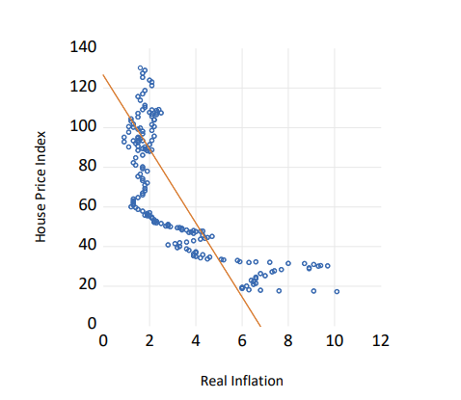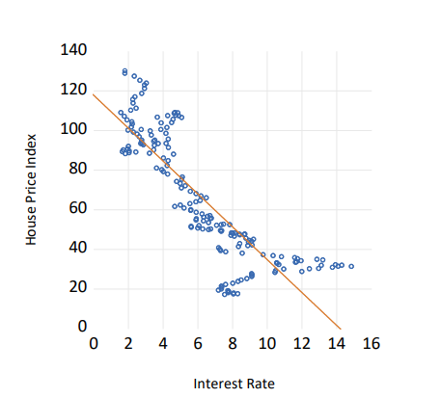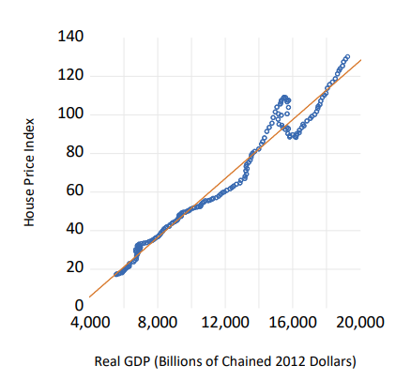

Plotting our independent variables against our dependent variable, which is our house price index, and drawing a linear line of best fit gives us some insight into the data. Firstly, there is an almost linear positive relationship between GDP and house prices. Theoretically, this makes sense because GDP growth leads to an increase in disposable income of the population, leading to more demand in house prices, which will increase prices. Although, we have tried to draw a linear line in the plots of the other two variables, we do not get an accurate line of best fit. This is because, although, the relationship between interest rate and house prices, and inflation and house prices are negative, we do not see a linear trend. However, negative trend makes sense because higher interest rates and higher inflation will lead to lower demand in houses, leading to lower prices.

Next, we try to build a linear model and the results are as follows:

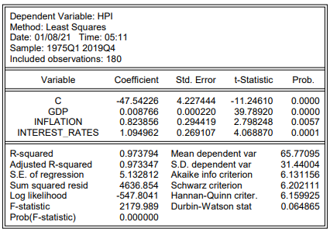

### Interpretations

According to our model the linear equation formed is as follows:

According to the model an increase of $1 billion in GDP will lead to an increase of 0.0087 percentage points in the house price index, keeping inflation rate and interest rate constant. Similarly, an increase of 1 percentage point in inflation will lead to an increase of 0.82 percentage points in the house price index, keeping the other two variables constant. Also, an increase of 1 percentage point in interest rate will lead to an increase of 1.09 percentage points in the house price index.

The p-values of all coefficients is less than the level of significance () indicating that all the coefficients have some effect on the house price index.

R-squared value is 0.973794, which means that the model explains 97.38% of the variability around the mean.

### Global f-test

Next, we test the overall relevance of our model for which we test whether the current model is better than the model where there are no independent variables. Since the p-value of the global f-test is less than the level significance (, we will reject the null hypothesis and conclude that the model is better than the one with only intercept value.

### Residual Normality Test

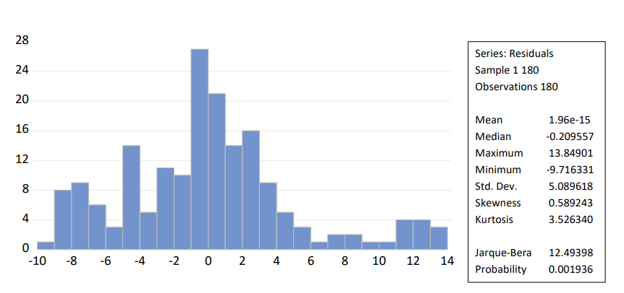

One of the assumptions of an unbiased regression model is that the error terms are normally distributed. To test whether it is true in our model, we apply Jarque-Bera test to check whether the error terms match the skewness and kurtosis of normal distribution. The test has a p-value less than the level of significance (. Therefore, we interpret that error terms are not normally distributed.

### Ramsay RESET Test

To test whether there is any model misspecification due to incorrect functional form or omitted variables, we conduct Ramsay RESET test. The p-value is 0.65, indicating that our model is correctly specified.

### Chow Test

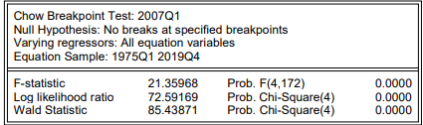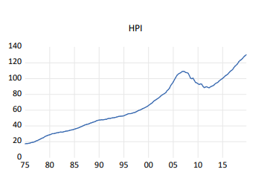

We see that there is a sudden spike in the house price index around the year 2007. Therefore, we conduct a chow test with structural break around this point to see whether the regression model fits the data better after the sudden spike. The p-value is less than the significant value, which means that the null hypothesis fails, and we conclude that there is a significant break at the specified breakpoint.

## Log-log Model

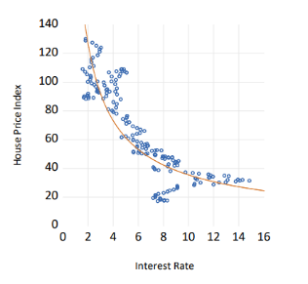We saw earlier that when we tried to plot a linear line, the line did not fit accurately in the variables inflation and interest rate. Therefore, we try to fit a log-log model and interpret its results.

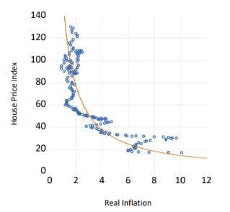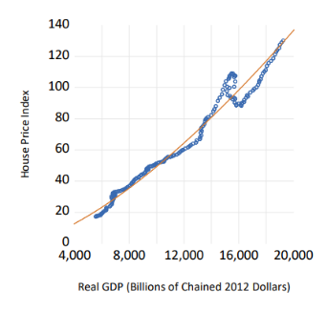

Plotting logarithmic regression, we see that the lines fit the data better.

### Interpretations

The equation of the regression model is as follows:

According to this model, an increase of 1 percent in real gdp will increase the house price index by 1.90 percentage points, keeping other variables fixed. An increase in inflation by 1 percent will increase house price index by 0.08 percentage points, keeping other variables fixed. And an increase in interest rate by 1 percent will increase the house price index by 0.22 percentage points keeping other variables fixed.

The probabilities of all t-tests of coefficients are less than the level of significance, indicating that all the variables have some effect on the house price index, which is our dependent variable.

R-squared value is 0.987872, which means that the model explains 98.78% of the variability around the mean. This is a better value than the previous model.

## Global F-test

The probability of the global f-test is less than the level of significance, which means that our model is better than a model with no independent variables.

### Residual Normality Test

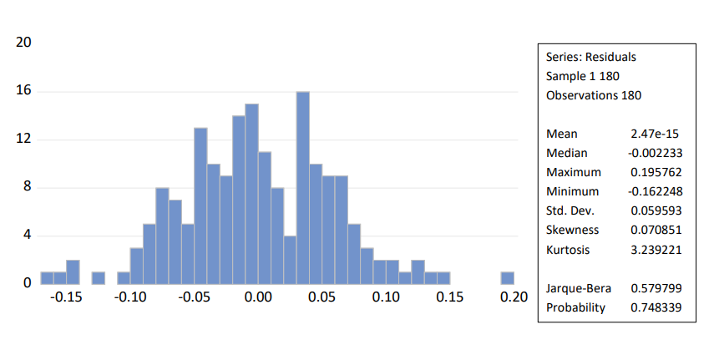

The probability is greater than the level of significance, indicating that the error terms are relatively normal. This is a better than result than the linear model.

### Ramsay Reset Test

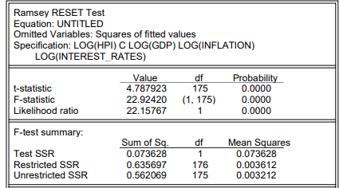

This model fails the Ramsay’s RESET test indicating that the model contains some misspecification. It may be due to omitted variables or incorrect use functional form.

### Chow Test

Chow test indicates that there is a significant difference in elasticities around the year 2007.

# UK

## Log-log Model

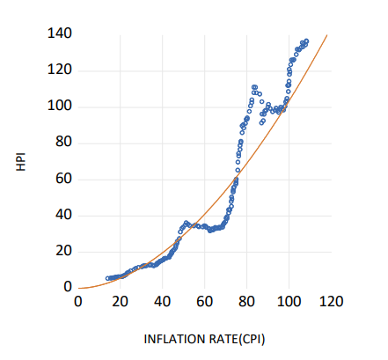

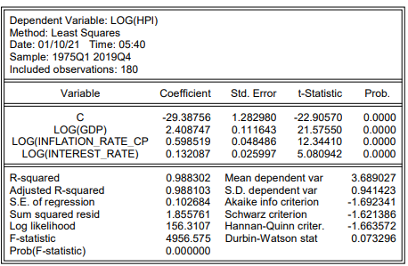

### Interpretation

The equation of the equation is as follows:

According to this model, an increase of 1 percent in real gdp will increase the house price index by 2.41 percentage points, keeping other variables fixed. An increase in inflation by 1 percent will increase house price index by 0.5985 percentage points, keeping other variables fixed. And an increase in interest rate by 1 percent will increase the house price index by 0.132 percentage points keeping other variables fixed.

The probabilities of all t-tests of coefficients are less than the level of significance, indicating that all the variables have some effect on the house price index, which is our dependent variable.

R-squared value is 0.9883, which means that the model explains 98.83% of the variability around the mean.

### Global F-test

The probability of the global f-test is less than the level of significance, which means that our model is better than a model with no independent variables.

### Residual Normality Test

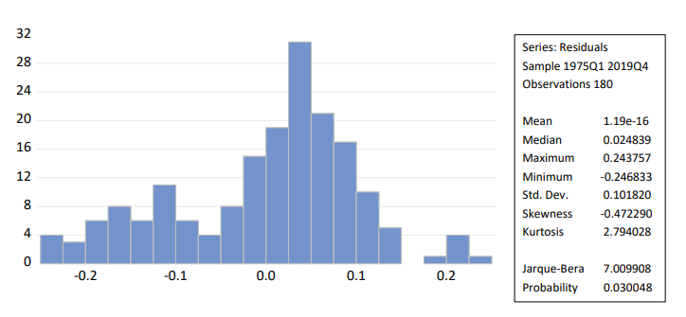

The p-value of the Jarque Bera Test is than the level of significance, indicating that the error terms are not normally distributed. However, since our sample is large enough, we can safely assume normality.

### Ramsay Reset Test

According to the Ramsay’s RESET Test, we fail to reject the null hypothesis and conclude that our model does contain any misspecification.

### Chow Test

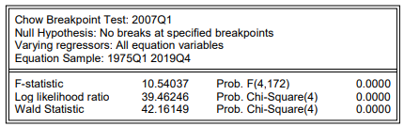

Chow test indicates that there is a significant difference in elasticities around the year 2007.

# GERMANY

For this model, we use Real GDP index instead of absolute values of GDP. This is due to non-availability of relevant data.

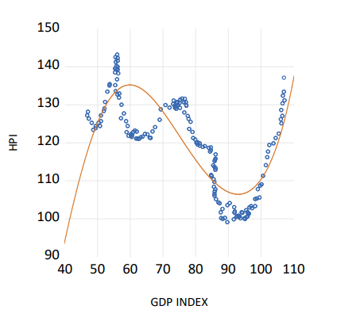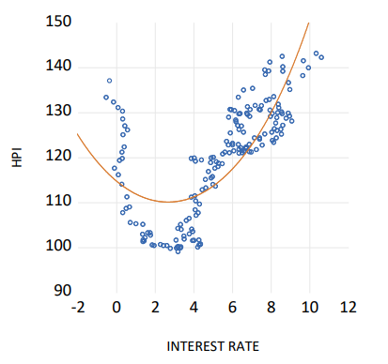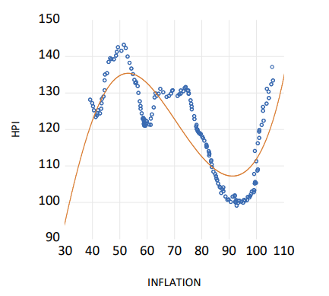

According to the scatterplots, GDP Index and Inflation has cubic relationship with House Price Index. And Interest Rate has a quadratic relationship with House Price Index. Therefore, we make our regression accordingly.

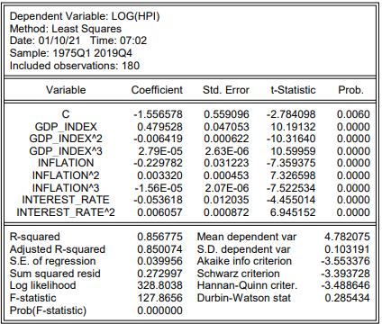

### Interpretation

The equation of the regression model is as follows:

### Marginal Effect

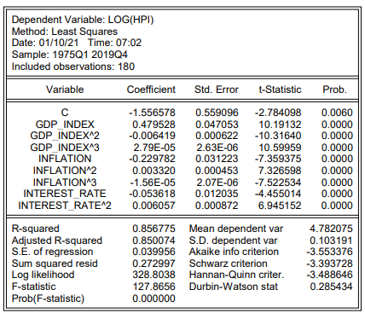

### Global F-test

The probability of the global f-test is less than the level of significance, which means that our model is better than a model with no independent variables.

### Residual Normality Test

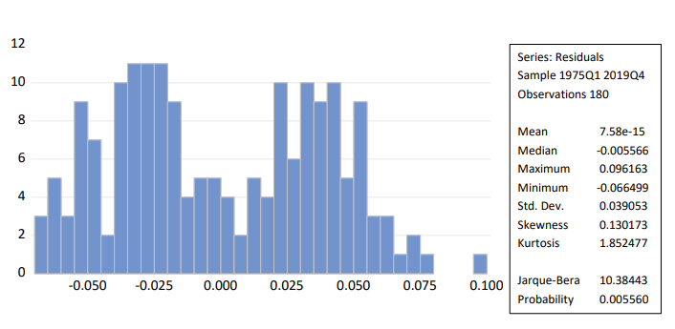

The p-value of the Jarque Bera Test is than the level of significance, indicating that the error terms are not normally distributed. However, since our sample is large enough, we can safely assume normality.

### Ramsay RESET Test

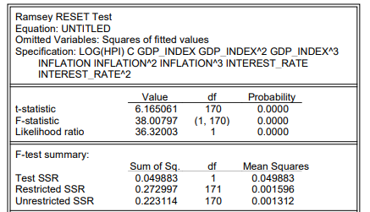

This model fails the Ramsay’s RESET test indicating that the model contains some misspecification. It may be due to omitted variables or incorrect use of functional form.

### Chow Test

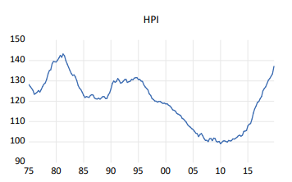

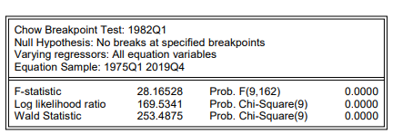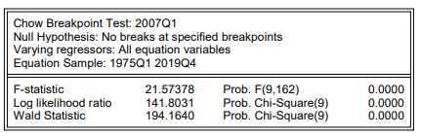

We see that there is a sudden spike in the house price index around the year 2007 and 1982. Therefore, we conduct a chow test with structural break around this point to see whether the regression model fits the data better after the sudden spike. The p-value is less than the significant value, which means that the null hypothesis fails, and we conclude that there is a significant break at the specified breakpoints.

# Conclusion

The models and tests applied in this paper show significant evidence that inflation, GDP growth, and real interest rate do have an impact on real estate prices. Our models have relevance because they all passed the global F-test. However, we did find misspecification in the regression model for all three countries when we used the Ramsay RESET test. This is possibly because we have not taken under account many other macroeconomic variables such as population, urbanization, et cetera. This also shows that there is a lot of potential for future research concerning various determinants that impact real estate prices, and consequently a county’s economy. Accounting for all of them was not possible within the scope of this paper.

# References

Tripathi. (2019). Macroeconomic Determinants of Housing Prices: A Cross Country Level Analysis. *National Research University Higher School of Economics.* Retrieved from: <https://mpra.ub.uni-muenchen.de/98089/1/MPRA_paper_98089.pdf>

Meidani, A., Zabihi, M., Ashena, M. (2011). House prices, Economic Output, and Inflation Interactions in Iran. *Research in Applied Economics*. Retrieved from: <https://www.researchgate.net/publication/228429516_House_prices_Economic_Output_and_Inflation_Interactions_in_Iran>

Ćetković, J., Lakić, S., Lazarevska, M., Žarković, M., Vujošević, S., Cvijović, J., & Gogić, M. (2018). Assessment of the real estate market value in the european market by artificial neural networks application. *Complexity*. Retrieved from: <https://www.hindawi.com/journals/complexity/2018/1472957/>

Cohen, V., & Karpaviciute, L. (2017). The analysis of the determinants of housing prices. *Independent Journal of Management & Production*, *8*(1), 49-63. Retrieved from: <https://www.redalyc.org/pdf/4495/449549996005.pdf>

U.S. Bureau of Economic Analysis, Real Gross Domestic Product [GDPC1], retrieved from FRED, Federal Reserve Bank of St. Louis; https://fred.stlouisfed.org/series/GDPC1, January 6, 2021.

Mack, A., and E. Martínez-García. 2011. "A Cross-Country Quarterly Database of Real House Prices: A Methodological Note." Globalization and Monetary Policy Institute Working Paper No. 99, Federal Reserve Bank of Dallas.

Organization for Economic Co-operation and Development, Long-Term Government Bond Yields: 10-year: Main (Including Benchmark) for the United States [IRLTLT01USQ156N], retrieved from FRED, Federal Reserve Bank of St. Louis; https://fred.stlouisfed.org/series/IRLTLT01USQ156N, January 7, 2021.

U.S. Bureau of Economic Analysis, Personal Consumption Expenditures (PCE) Excluding Food and Energy (chain-type price index) [DPCCRV1Q225SBEA], retrieved from FRED, Federal Reserve Bank of St. Louis; https://fred.stlouisfed.org/series/DPCCRV1Q225SBEA, January 7, 2021.

Bank for International Settlements, Residential Property Prices for United Kingdom [QGBN628BIS], retrieved from FRED, Federal Reserve Bank of St. Louis; https://fred.stlouisfed.org/series/QGBN628BIS, January 9, 2021

Organization for Economic Co-operation and Development, Consumer Price Index of All Items in the United Kingdom [GBRCPIALLQINMEI], retrieved from FRED, Federal Reserve Bank of St. Louis; https://fred.stlouisfed.org/series/GBRCPIALLQINMEI, January 9, 2021.

Eurostat, Real Gross Domestic Product for United Kingdom [CLVMNACSCAB1GQUK], retrieved from FRED, Federal Reserve Bank of St. Louis; https://fred.stlouisfed.org/series/CLVMNACSCAB1GQUK, January 8, 2021.

Organization for Economic Co-operation and Development, Long-Term Government Bond Yields: 10-year: Main (Including Benchmark) for the United Kingdom [IRLTLT01GBQ156N], retrieved from FRED, Federal Reserve Bank of St. Louis; https://fred.stlouisfed.org/series/IRLTLT01GBQ156N, January 9, 2021.

Bank for International Settlements, Real Residential Property Prices for Germany [QDER628BIS], retrieved from FRED, Federal Reserve Bank of St. Louis; https://fred.stlouisfed.org/series/QDER628BIS, January 9, 2021.

Organization for Economic Co-operation and Development, Consumer Price Index of All Items in Germany [DEUCPIALLQINMEI], retrieved from FRED, Federal Reserve Bank of St. Louis; https://fred.stlouisfed.org/series/DEUCPIALLQINMEI, January 9, 2021.

Organization for Economic Co-operation and Development, Long-Term Government Bond Yields: 10-year: Main (Including Benchmark) for Germany [IRLTLT01DEQ156N], retrieved from FRED, Federal Reserve Bank of St. Louis; https://fred.stlouisfed.org/series/IRLTLT01DEQ156N, January 9, 2021.

Organization for Economic Co-operation and Development, Gross Domestic Product by Expenditure in Constant Prices: Total Gross Domestic Product for Germany [NAEXKP01DEQ661S], retrieved from FRED, Federal Reserve Bank of St. Louis; https://fred.stlouisfed.org/series/NAEXKP01DEQ661S, January 9, 2021.